**The role of conical intersections in excitation energy transfer: a theoretical study of bridged xylene - diacetyl dyads**

Carl F. Burmeister1,† Martial Boggio Pasqua2,†,* Dmitry Morozov4 Michael A. Robb3, Gerrit Groenhof4,*

1Department of Theoretical and Computational Biophysics, Max-Planck-Institute for

Biophysical Chemistry, Am Fassberg 11, 37077 Göttingen, Germany

2Laboratoire de Chimie et Physique Quantiques - IRSAMC, CNRS et Université de

Toulouse 3, 31062 Toulouse, France

3Chemistry department, Imperial College, London SW 7 2AZ, United Kingdom

4Department of Chemistry and Nanoscience Center, University of Jyväskylä, P. O.

Box 35, 40014 Jyväskylä, Finland

†Authors contributed equally

*Correspondence to: gegroenh@jyu or martial.boggio@irsamc.ups-tlse.fr

**Abstract**

A prominent example of light-driven energy transportation is the process of photoinduced electronic energy transfer (EET), in which electronic excitation is exchanged between two chromophores. Our understanding of how EET occurs at the molecular level is still rather limited and based on first-order perturbation theory approaches (Förster/Dexter). Here we have used ab initio computations and nonadiabatic molecular dynamics simulations at the complete active space self-consistent field (CASSCF) level of theory, to study the intramolecular EET process in cyclic bichromophoric systems containing benzene (donor) and α-diketone (acceptor) moieties. The results show that EET occurs when the nuclear trajectory evolves on a high-dimensional potential energy surface from an initial reactant excited state, in which the excitation is localized on the donor, to a product excited state, in which the excitation is localized on the acceptor, via conical intersections. The weakening of the EET efficiency upon increasing the distance between the donor and acceptor moieties is rationalized by a decrease of the nonadiabatic coupling at the conical intersections.

**1. Introduction**

The transfer of excitation energy between chromophores is an important process in biology and chemistry. In photosynthesis special antennae complexes harvest light, but the absorbed energy must be transferred into another part of the system to be used. The process of Fluorescence Resonance Energy Transfer (FRET), where light is absorbed in one part of the system and emitted in another part, has become one of the most important tools for studying structure and dynamics of biological systems.[1],[2] However, in both examples, our understanding of how energy transfer occurs at the molecular level is still rather limited and mostly based upon empirical theories, such as Förster[3],[4],[5],[6] and Dexter[7] theory that cannot be used to design new systems. The aim of this work therefore is to provide a general theoretical framework, based on multi-dimensional potential energy surfaces (PES) for excitation energy transfer (EET).

The current working model of EET is based on first-order perturbation theory, or Fermi’s Golden Rule (FGR).[8] Within this approach the chromophores are usually treated separately, while the perturbation driving EET is treated as the electrostatic interaction between the non-interacting chromophores. Recent theoretical works have focused on the development of accurate methods for computing the electronic coupling, as well as incorporating the influence of the environment.[9] However, as one of the main assumptions in the FGR treatment is that the EET occurs substantially slower than nuclear relaxation dynamics,8 relatively few studies have concentrated on the effect of nuclear dynamics on the EET process, with most of these studies focusing on the effect of dynamics on the fluctuations in the excitation energies of the individual chromophores and their mutual couplings.[10] Despite the success of the FGR approach in predicting EET rates, the observation of efficient energy transfer between chromophores with very weak interactions,[11],[12],[13] or of long-lived coherences in light harvesting complexes,[14],[15],[16],[17] are difficult to reconcile with the static first order approach, and challenge its general validity. Furthermore, the essentially one-dimensional Förster and Dexter models are not easily inverted (?) to design new systems, and so far only the concept of spectral overlap has been exploited to control the direction of EET in artificial systems.[18] These observations suggest that a more general framework is desired that not only explains the observed discrepancies with the FGR model, but also provides new design principles for constructing artificial systems.



**Figure 1.** Series of bichromophoric systems studied.

Here we used ab initio quantum chemistry approaches in combination with on-the-fly nonadiabatic molecular dynamics (MD) simulations to provide evidence for an alternative EET mechanism that is based on chemical reaction pathways on nonadiabatically coupled PES. Our investigation is focused on bridged bichromophoric systems shown in Figure 1. These dyads are macrocyclic α-diketones incorporating a para-substituted benzene ring. After photoexcitation to the (π,π*) state on benzene, EET takes place to the (n,π*) state on the α-diketone moiety. By varying the length of the linkers connecting the two chromophore units, Speiser and co-workers were able to control the distance and relative orientation between the chromophores.[19],[20] We use the nomenclature of Speiser *et al.* and refer to these dyads as P*nn*, where *n* indicates the number of carbon atoms in the linker. In the smallest dyad, with four aliphatic carbon atoms in both linkers (i.e. P44), excitation of benzene at 268 nm induces fluorescence of α-diketone at 480 nm with 99% efficiency, while the EET quantum yield drops to 84% and 74% in P55 and P66, respectively.[21],[22] Our calculations provide a mechanistic picture of the EET mechanism based on nonadiabatic pathways involving conical intersections, accounting for the excellent EET efficiency in P44 and for its decrease in P55 and P66.

**2. Theory**

Within the FGR framework,8 the rate (*k*) of EET between two chromophores is expressed as:

$k=\frac{2π}{ℏ}\sum_{f}{{\left|\left\langle i | \hat{H} | f\right\rangle \right|}^{2}ρ\left(E\right)}$ (1)

where *i* and *f* are the initial and final states with the excitation localized on the donor (D*A) and acceptor (DA*), respectively. The matrix element $\left\langle i | \hat{H} | f\right\rangle$ represents the electronic coupling between *i* and *f*, and $ρ\left(E\right)$ is the density of states isoenergetic with *i* in the final manifold of states *f*. Within this approach the chromophores can be treated separately, while the perturbation driving EET is treated as the electrostatic interaction between the transition densities of the non-interacting chromophores.

Early theoretical models of photochemical reactions were based on FGR as well,[23] but with the advent of femtosecond spectroscopy it became clear that FGR under predicts the rates by orders of magnitude. Instead, these new experimental observations suggested the involvement of surface crossings,[24],[25] the so-called conical intersections (Fig. 2a). Around a point of intersection, the degeneracy between adiabatic electronic states $ψ_{1}$ and $ψ_{2}$ is lifted (to first order) in a two-dimensional subspace (called branching space)[26] spanned by the gradient difference vector $g=∇_{R}\left(E_{1}-E_{2}\right)$ and the derivative coupling vector $h=\left\langle 1 | ∇_{R}H | 2\right\rangle$, with $∇_{R}$ the gradient with respect to all nuclear coordinates ($R$), and *H* the electronic Hamiltonian. When projected onto this plane, the intersecting surfaces exhibit the typical double cone topology, with the point of degeneracy at the apex (Fig. 2a). Orthogonal to this two-dimensional branching space exists the so-called intersection space (or seam space), in which the energies of the two states remain degenerate to first order. In a molecule with *n* internal degrees of freedom, the intersection space thus forms a *n*-2 dimensional seam, each point of which is a conical intersection.[27],[28]

Despite the fact that EET also involves transitions between electronic states that are close in energy, the role of conical intersections in EET has not been systematically explored. Mainstream thinking about EET is still dominated by FGR instead. In practical applications, the density of states is approximated by the spectral overlap between the donor emission and acceptor absorption spectra, while the electronic coupling is expanded in a multipole series, usually truncated after the dipole-dipole term (Förster).3-6 For shorter inter-chromophore separations, the full transition density can be used.[29] At very short distances at which the orbitals overlap significantly, the electronic coupling is dominated by exchange interactions, which are accounted for by Dexter’s theory.7 The chromophores are treated as static and isolated entities (diabatic representation) and the couplings are typically computed at the ground state geometries.

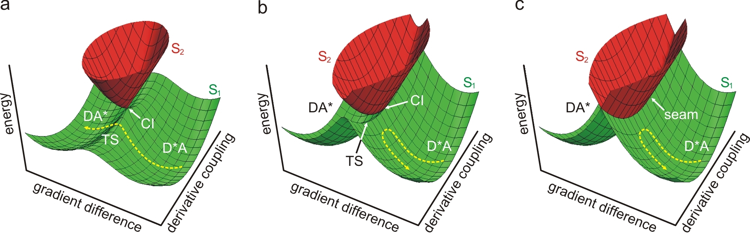

**Figure 2.** At a conical intersection (CI) the degeneracy is lifted by motion along two coordinates. If the nonadiabatic coupling between the adiabatic electronic states S1 and S2 is strong along the derivative coupling coordinate a typical double cone results (a). The energy splitting opens up a transition state (TS) for the EET. If coupling is weak, TS is higher in energy (b), while if there is no coupling, the surfaces intersect and passage to the product is blocked (c).

However, our thinking about chemistry is most conveniently done in the adiabatic representation, in which the electronic Hamiltonian is diagonal (*i.e.,* no off-diagonal electronic couplings between different electronic states) and changes in electron distribution (*i.e.,* bonding) are induced by nuclear motions. We therefore set out to investigate EET within the adiabatic framework instead and describe the process in terms of nuclear reaction coordinates. In particular, we go beyond the zero-dimensional FGR approach and include the full dimensionality of the system. However, to illustrate the concept, only two coordinates are essential.

In EET the excitation migrates from one chromophore to the other, which in the chemist’s view, should occur along a reaction pathway that takes the system from the D*A minimum on the excited state PES, in which the excitation is localized on the donor, to the DA* minimum, in which the excitation is localized on the acceptor (Fig. 2a). The reaction coordinate must thus involve motions that change the donor geometry from its excited to ground state geometry, while simultaneously change the acceptor geometry from the ground to excited state geometry. As such coordinate tunes the energy gap between the electronic states it is related to the spectral overlap in Förster theory, and contains a component parallel to the gradient difference vector **g**. However, the conical intersection between the adiabatic S1 and S2 states must be avoided, because crossing the intersection to the higher excited state will not change the electronic character of the excitation (*i.e.*, after passage the excitation will still be located on the donor). Because the degeneracy is lifted at the conical intersection by displacement not only along the tuning vector (**g**), but also along the coupling vector (**h**), it is clear that the reaction coordinate must contain a component parallel to **h** as well. The nonadiabatic coupling induced by displacements along **h** changes the intersection into an avoided crossing. On the lower surface this avoided crossing is the transition state that forms the dynamic bottleneck for the EET process. While the nuclear trajectory passes the transition state, the nonadiabatic coupling smoothly changes the total electronic wave function from D*A to DA* (Fig. 2a).

Summarizing, our description is based on a two-dimensional picture in which EET requires displacement along both the gradient difference (tuning, **g**) and derivate coupling (**h**) vectors. The efficiency of EET is controlled by the location of the conical intersection and the topology of the S1 and S2 adiabatic surfaces (in the case where D*A and AD* correlates with S1 and S2, respectively): The nonadiabatic coupling along the derivative coupling must be strong enough to create an energetically accessible transition state on the lower surface. If the nonadiabatic coupling is too weak, reaching the transition state will require a large and energetically costly displacement in the direction of **h** (Fig. 2b) and EET will be inefficient. If the nonadiabatic coupling vanishes, the intersection seam becomes *N*-1 dimensional and cannot be avoided. In this case, the system is diabatically trapped and the excitation will remain on the donor (Fig. 2c). Note that in the particular case of a very strong coupling, a new minimum appears along **h**, in which the excitation is shared between the chromophores (exciton), and the transfer will be coherent (quantum transport), rather than incoherent (hopping).

In the following we provide computational evidence based on static and dynamical information that the EET process in Speiser’s Pnn (n=4–6) dyads can be understood in terms of a nonadiabatic pathway evolving from a reactant state in which the excitation is localized on the benzene moiety to a product state in which the excitation is localized on the diketone moiety. The article is organized as follows. First, we provide some computational details about the quantum chemical calculations and dynamics simulations. Then, we discuss two possible mechanistic scenarios for EET based on static information obtained from the topological features of the PES. Finally, the mechanistic picture is completed by our nonadiabatic dynamics simulations.

**3. Methods**

The ground state geometries of P44, P55 and P66 were optimized at the density functional level of theory, using the B3LYP functional[30] and 6-31G* basis set.[31],[32] Because of the inherent flexibility of the aliphatic linkers, we considered different configurations that we classify as *compact*, *intermediate* or *extended* (Fig. S1 and Fig. 3), according to the distance between the centers of mass of the chromophores. Other configurations were too high in energy and were not considered. The transition states linking these three isomers were computed for the P44 dyad, in order to get some information on the activation energies involved to switch from one isomer to the other. The intrinsic reaction coordinates[33] were calculated to calculate the minimum energy paths from these transition states.

Ground- and excited-state PES were then investigated using the complete active space self-consistent field (CASSCF) level of theory. Minima on the three lowest-energy excited state PES were optimized using state-specific (SS) CASSCF(*n*,*m*)/6-31G* calculations, where *n* and *m* denotes the number of active electrons and orbitals, respectively. In these calculations the complete π valence active space was used for the ground state and the first (π,π*) excited state, requiring CASSCF(10,10) calculations. To compute the (n,π*) excited states, two additional oxygen lone pair orbitals (one on each oxygen atom of the diketone) had to be included, which generated demanding CASSCF(14,12) calculations. In addition to optimizing the local minima on the four PES, we also searched for conical intersections between these surfaces. Then, the energies were all computed at all the critical structures using state-averaged (SA) calculations between the four states and using the large active space (i.e., SA4-CASSCF(14,12)), so that relative energies can be computed at the same level of calculation. Internally-contracted multireference second-order perturbation theory (CASPT2)[34] calculations were also performed with the correlation-consistent cc-pVDZ basis set[35] in order to verify the validity of the CASSCF results.

In the nonadiabatic QM/MM MD simulations the P44 dyad was described at the SA4-CASSCF(14,12)/6-31G* level of theory. The use of reduced active spaces[36] in on-the-fly CASSCF dynamics simulations[37] was prohibited due to the deterioration of the excited-state potential energy landscapes upon reducing the size of the active space. Thus, we were limited in the number of trajectories that could be computed because of the high cost caused by the use of this very large active space. An explicit hexane solvent was modeled with the Gromos96 force field,[38] and mechanical embedding was used to couple the QM and MM subsystems. We used two approaches to model radiationless transitions between the excited-state PES. One set of trajectories was computed using a diabatic surface hopping algorithm (DH),[39],[40],[41] while the second set was computed using Tully's fewest switches hopping (FS)[42],[43],[44] with the decoherence correction proposed by Persico and co-workers.[45] All simulations were stopped shortly after reaching the lowest (n,π*)-state of the α-diketone moiety.

Prior to the nonadiabatic simulations, the total system, consisting of 6950 atoms was equilibrated at a temperature of 300 K and a pressure of 1 atmosphere at the MM level (atomic charges and force field parameters as well as simulation protocols are available in Supporting Information). Since the CASSCF wave function is very sensitive to the initial geometry, we could only unambiguously track the excited state character in five of the trajectories (3 DH, 2 FS), and will restrict our discussion to these cases. In the other trajectories, one or more of the relevant states could not be identified (assigned?) in the initial geometry. In the diabatic hopping simulations, we varied the integration step size from 0.1 fs to 1 fs, and found that the overall dynamics did not depend on the step size. All computations were performed with Molpro2009[46] and Gromacs4.5.[47]

**4. Results**

We will first present the results of the *ab initio* computations and show that the optically active (π,π*) state localized on benzene and the fluorescent (n,π*) states on α-diketone are connected via conical intersections and that there exists two possible nonadiabatic pathways for the EET process, which involves passages through these intersections. We then discuss the results of the MD simulations, which confirm the results from the ab initio calculations that EET process in P44 is a succession of nonadiabatic decays to the lowest excited state PES.

***4.1 Static picture of the EET mechanism***

Figure 3 shows the minimum energy path on the ground-state (GS) PES along the isomerization coordinate connecting the *compact*, *intermediate* and *extended* conformers of P44. The *compact* conformer is characterized by the shortest inter-chromophore distance (ca. 3.4 Å) and represents the lowest energy structure on the S0 PES. A barrier of 0.22 eV needs to be overcome to reach the *intermediate* conformer (inter-chromophore distance of ca. 3.8 Å) lying less than 0.05 eV above the *compact* one. Then, a slightly higher barrier of 0.28 eV is involved to reach the *extended* conformer (inter-chromophore distance of ca. 4.3 Å), which lies less than 0.08 eV above the *compact* structure. The small energy differences between the three conformers along with the weak isomerization barriers involved suggest that all these structures can participate in the EET process at room temperature. Thus, we have investigated in the following the excited states of P44 considering the three conformers.



**Figure 3.** Intrinsic reaction coordinate (IRC) along the isomerization coordinate (Rx) connecting the *compact*, *intermediate* and *extended* conformers of P44 computed with B3LYP/6-31G*. SA4-CASSCF(14,12)/6-31G* values are indicated in parentheses.

The order and nature of the three lowest excited states are illustrated in Figure 4. At the GS *compact* geometry, the lowest two excited states are of (n,π*) character and localized on the α-diketone moiety, while the third excited state is of (π,π*) character and localized on the benzene ring. The excited states were then optimized to find the local minima on each PES and conical intersections between all these states were systematically located. The geometrical structures of all these critical points are shown in Supp. Info. (Tables S1-S3) and their relative energies are collected in Table 1 (Table S4 in Supp. Info. for *intermediate* and *extended* conformers).

Write (n,π*)1, (n,π*)2, and (π,π*)

Correct the error in MOs for (π,π*) transitions!

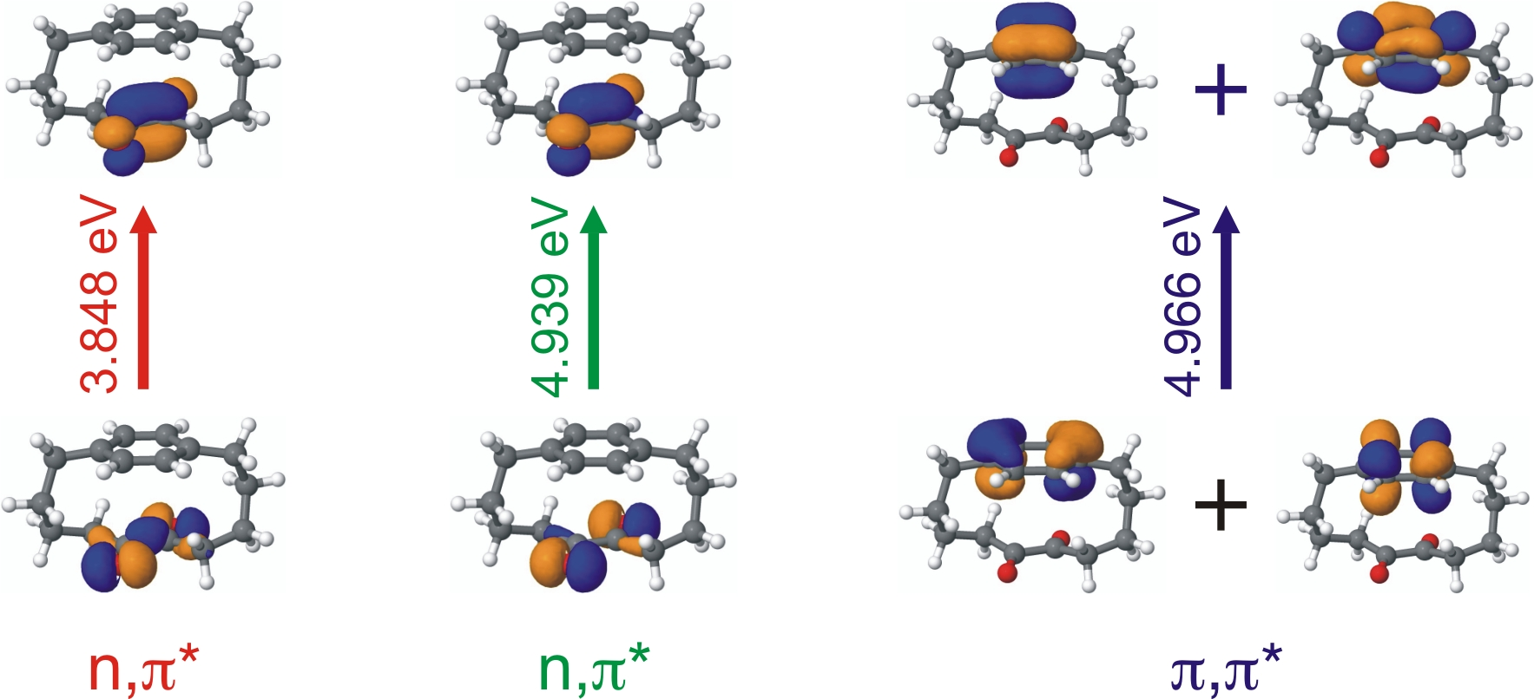

**Figure 4.** Three lowest energy excited states of P44 dyad in the *compact* minimum energy geometry at the SA4-CASSCF(14,12)/6-31G* level of theory. Comparisons to different levels of theory and experiment are included in Supporting Information.

**Table 1.** Relative energies*a* (in eV) of all the critical structures of the *compact* P44 dyad at the SA4-CASSCF(14,12)/6-31G* level.

|  |  |  |  |  |
| --- | --- | --- | --- | --- |
| Structures*b* | ΔE GS | ΔE (n,π*)1 | ΔE (n,π*)2 | ΔE (π,π*) |
| GS *C*2 min | **0** | 3.848 | 4.939 | 4.966 |
| (n,π*)1 *C*2 min | 0.367 | **3.519** | 4.192 | 5.337 |
| (n,π*)2 *C*2 min | 1.008 | 3.621 | **4.036** | 5.974 |
| (π,π*) *C*2 min | 0.219 | 4.074 | 5.163 | **4.742** |
| (n,π*)1/(n,π*)2 *C*2 MECI | 5.591 | **5.972** | **5.986** | 9.764 |
| (n,π*)2/(π,π*) *C*2 MECI | 0.167 | 3.810 | **4.750** | **4.784** |
| (n,π*)1/(π,π*) *C*2 MECI | 0.570 | **4.829** | 5.713 | **4.899** |

*a* The energies are given relative to the GS minimum. The values in bold font correspond to the relevant states at each critical structure. *b* The structures are computed at SS-CASSCF(10,10) level for GS and (π,π*) minima, at SS-CASSCF(14,12) level for (n,π*)1 and (n,π*)2 minima, and at SA2-CASSCF(14,12) level for minimum energy conical intersections (MECI).

Based on the these results and the nature of the relaxation coordinates involved, we have determined schematic potential energy profiles of the four lowest adiabatic states in the *compact* conformation of P44 (Fig. 5). At the GS minimum, the gap to the optically active (π,π*) state is 4.966 eV. The minimum on the (π,π*) state lies 0.224 eV below the Franck-Condon (FC) region. Very near this minimum, there is a minimum energy conical intersection (MECI) with the (n,π*)2 state that is localized on the α-diketone. This intersection is located at only 0.042 eV above the global minimum of the (π,π*) state, and has to be crossed to reach the (π,π*) minimum, which thus lies on the second excited-state PES. However, at this conical intersection the gradient difference **g** and derivative coupling **h** vectors are antiparallel (Fig. 5, inset a) so that there is only one degree of freedom available to lift the degeneracy at the (n,π*)2/(π,π*) MECI. Thus, this crossing is not a conical intersection but a (*n*-1)-dimensional crossing seam. Along the unique degeneracy-lifting coordinate, which corresponds to the reaction coordinate, crossing the seam will not change the character of the electronic state, and the system will stay on the (π,π*) diabatic state (Fig. 5, inset a add 2D conical intersection as for inset b).

At 0.157 eV above the (π,π*) minimum (*i.e.* 0.067 eV below the FC point) we found a conical intersection that connects the (π,π*) state on the benzene with the lowest (n,π*)1 state on α-diketone. In contrast to the previous intersection, the gradient difference and derivative coupling vectors are perpendicular at this intersection. Therefore, the branching space of this conical intersection is two-dimensional. Furthermore the conical intersection is sloped26 (*i.e.* the gradients have the same sign). Upon decay at this intersection, the electronic state will change from (π,π*) character localized on the benzene ring to (n,π*) character localized on the diketone (Fig. 5, inset b). Following further vibrational relaxation on the lowest excited-state PES, the system reaches the (n,π*)1 minimum. Because we have not been able to find a conical intersection between this state and the electronic ground state, we assume that further decay will only occur through fluorescence. Thus, one possible EET pathway based on these static information can be summarized as follows: upon excitation to the (π,π*) state, the system relaxes on the corresponding third excited-state PES until it reaches a (n-1) dimensional (n,π*)2/(π,π*) crossing seam. Here, a diabatic transition maintains the system on the diabatic (π,π*) state but a transition to the second excited-state PES occurs. The system further relaxes to reach the (π,π*) minimum on this PES, where it can easily reach a funnel for nonradiative decay down to the first excited-state PES in the form of a sloped conical intersection with the (n,π*)1 state. Upon decay at this crossing, the system then further relaxes to reach the (n,π*)1 minimum, where radiative decay is the most probable deactivation channel.

However, a second possible EET route can be proposed. Indeed, upon reaching the (n-1) dimensional (n,π*)2/(π,π*) crossing seam, because the derivative coupling is not negligible (unlike the case shown in Fig. 2c), it is also possible that the system undergoes a nonadiabatic transition (instead of a diabatic transition as in the first scenario). In such a case, the system will decay from the (π,π*) state to the (n,π*)2 state. Vibrational relaxation will then drive the system to the (n,π*)2 minimum from which a conical intersection between the two diketone (n,π*) states is probably accessible. While this conical intersection, denoted (n,π*)1/(n,π*)2 MECI, is about 1 eV higher in energy than the (π,π*) FC point and thus in principle not reachable with the energy available, the sloped nature of this funnel means that the energy gap between the two (n,π*) states will remain small for a large range of geometries at which decay is possible. Moreover, in the *intermediate* configuration, this conical intersection is located at 4.94 eV above the GS minimum (Table S4 in Supp. Info.), which is slightly below the FC energy at 4.96 eV and thus energetically accessible.

To summarize, our ab initio results suggest a crucial role of conical intersections in the intramolecular EET process in P44. In the picture emerging from these calculations, the EET process is governed by nuclear motions that, after excitation to the (π,π*) state on benzene (donor), steer the system towards the intersection seam between the bright (π,π*) state localized on benzene and the lowest energy dark (n,π*)1 state on α-diketone (acceptor). Two distinct EET pathways illustrated in Figure 6 can be distinguished depending on the nature of the radiationless transition at the first encountered crossing seam. In the case of a diabatic transition at the (n,π*)2/(π,π*) crossing seam, the (n,π*)2 state will not be transiently populated and the system will decay directly to the lowest (n,π*)1 state at a subsequent funnel. The complete pathway can thus be summarized as: (π,π*) FC→(n,π*)2/(π,π*) MECI→(π,π*) min→(n,π*)1/(π,π*) MECI→(n,π*)1 min (Fig. 6a). In the case of a nonadiabatic transition at the (n,π*)2/(π,π*) crossing seam, the (n,π*)2 state is transiently populated before decay to the lowest (n,π*)1 state occurs at a third funnel. This pathway can be recapitulated as: (π,π*) FC→(n,π*)2/(π,π*) MECI→(n,π*)2 min→(n,π*)1/(n,π*)2 MECI→(n,π*)1 min (Fig. 6b). Note that in both cases, there is no EET adiabatic pathway like the one shown in Fig. 2a. This is due to the (n-1) dimensional (n,π*)2/(π,π*) crossing seam and to the sloped (n,π*)1/(π,π*) MECI.

Insert 2D CI seam as in inset b.

Add stretch near each arrow of GDV and shrink near each arrow of DCV

Write (π,π*), (n,π*)1 and (n,π*)2

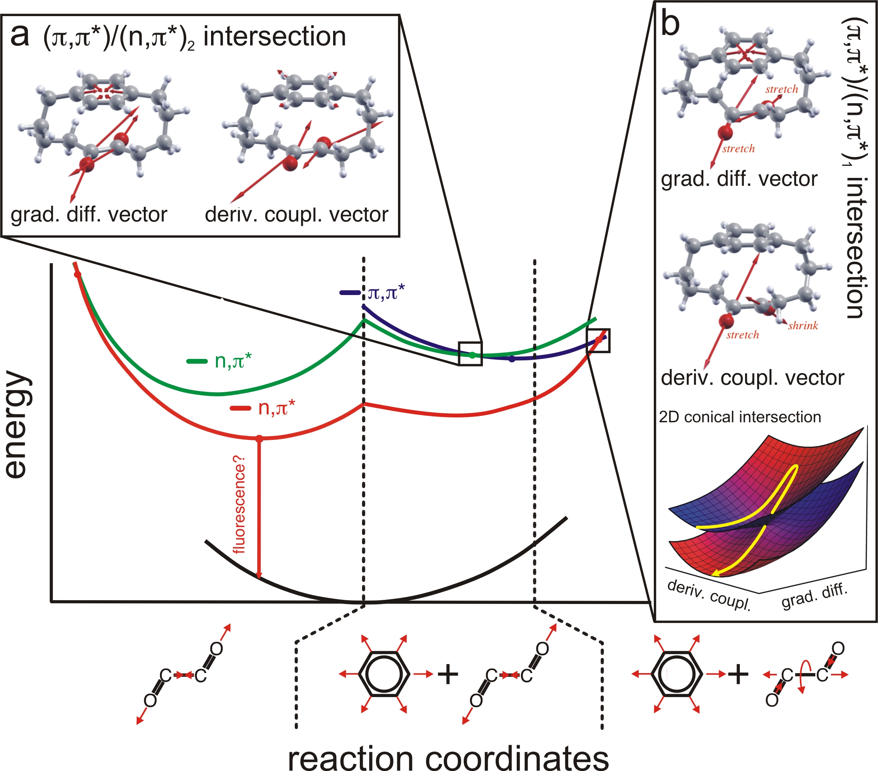

Figure 5. Schematic potential energy profiles of the first four electronic states in P44 in the *compact* conformation (see SI) The insets show the derivative coupling and gradient difference vectors that lift the degeneracy at the intersections at the two crossings between the (π,π*) on benzene and the two (n,π*) states on the diketone. The topology of the crossing in the branching space is also shown.

To understand why the efficiency of EET decays with increasing the bridge length, we repeated the computations for P55 and P66 (Tables S5-S10 in Supp. Info.). The energy profiles look very similar (compare Tables S4, S7 and S10 in Supp. Info.), and also the two crossings points between the (π,π*) and (n,π*) states were found to be below the FC energy. As in P44, the first (n,π*)2/(π,π*) crossing is one-dimensional in both P55 and P66, with antiparallel gradient difference and derivative coupling vectors. However, the derivative coupling at this crossing is significantly reduced in P66 by nearly an order of magnitude compared to P44. Thus, P66 will mainly follow the diabatic pathway (Fig. 6a). Although the second (n,π*)1/(π,π*) MECI is two-dimensional with perpendicular branching space coordinates, the derivative coupling becomes also more than an order of magnitude weaker in P66. Because of this weak nonadiabatic coupling, the radiationless decay from the (π,π*) state to the (n,π*)1 state becomes less probable and reducing the EET efficiency, in line with the experimental observation that EET has a lower yield in P66 than in P44 and P55.21,22



**Figure 6.** Schematic representation of the proposed pathways for the intramolecular EET process in P44 based (a) on a diabatic transition and (b) on a nonadiabatic transition, at the first encountered crossing seam. In both paths, the lowest lying (n,π*)1 state localized on diketone is reached, but only in the nonadiabatic pathway is the second (n,π*)2 involved.

***4.2 Dynamic picture of the EET mechanism***

To confirm the static picture derived from the ab initio calculations, we also performed nonadiabatic MD simulation of the P44 dyad in hexane solvent. We used two different algorithms to model the radiationless transitions in the trajectories. We first discuss the results of the diabatic surface hopping simulations, based only on the results of the trajectory that reached the final state in our simulations. The other trajectories follow the same path, but sample only the initial stage. Then, we discuss the results of Tully's fewest switches hoppingtrajectories. For a direct estimation of EET rates from the simulations, more and longer trajectories would be required, which is beyond the capabilities of our current computational resources.

*Diabatic surface hopping simulations.* In a snapshot of a ground-state equilibrium trajectory P44 was vertically excited into the (π,π*) state (Fig. 4), which was the second excited state in this configuration. In figure 7a we plot the potential energy of the relevant states as a function of the simulation time and trace out the nature of the electronic state in the trajectory. Within a few femtoseconds, the system reached the seam intersecting the benzene (π,π*) and second α-diketone (n,π*)2 states. observation is in line with the mechanistic picture in Fig. 6a provided by the ab initio results. At 10 fs the system crossed this seam again, but as before, remained diabatically trapped in the (π,π*) state. A little later, the system encountered the second seam at which the (π,π*) of benzene crosses with the lowest energy (n,π*)1 state of α-diketone. Upon reaching this funnel a *diabatic* surface hop occurred and the system ended up on the (n,π*)1 state after relaxation on the lowest excited-state PES. After this hop, the energy gaps with the other excited states rapidly increased, while the gap to the GS remains large. Therefore, we terminated the trajectory at 20 fs after the final hop. Although we cannot exclude that the system will undergo another hop later in time, we assume that the system will stay in the (n,π*)1 state during the radiative lifetime, which is typically a few nanoseconds and therefore beyond reach in our simulations. To justify our assumption we recall that we were not able to find conical intersections between GS and (n,π*)1. Thus, in this diabatic hopping trajectory, the EET process spontaneously took place within 20 fs. The observed mechanism is consistent with the first EET pathway proposed on the basis of the ab initio calculations (Fig. 6a).

*Tully's fewest switches hopping.* Also in two trajectories computed with Tully's fewest switches surface hopping method, the (π,π*) excitation rapidly decayed into the lowest energy (n,π*)1 state, but by a different mechanism (Figs. 7b and 7c). In contrast to the diabatic hopping trajectory (Fig. 7a), the second (n,π*)2 state became transiently populated during the EET process. During relaxation from the FC region, a surface hop took the system from the (π,π*) state on benzene to the (n,π*)2 state on diketone. After the first hop the system continued its dynamics on this (n,π*)2 state, until a second hopping event brought the system to the lowest (n,π*)1 state on diketone. Inspection of the trajectories revealed that the structures are close to the intermediate configuration, where the conical intersection between the two (n,π*) states is accessible. After the second surface hop, the gap with the (π,π*) and (n,π*)2 PES increased, and the system became trapped in the (n,π*)1 state. Again, we stopped the trajectories at this point and assume the next decay process will be fluorescence to the ground state. Thus, this mechanism is consistent with the second EET pathway proposed on the basis of the ab initio calculations (Fig. 6b).

Write benzene instead of xylene. Write (π,π*), (n,π*)1 and (n,π*)2. Use dark blue for (π,π*) and the associated energy curve. Use eV for consistency

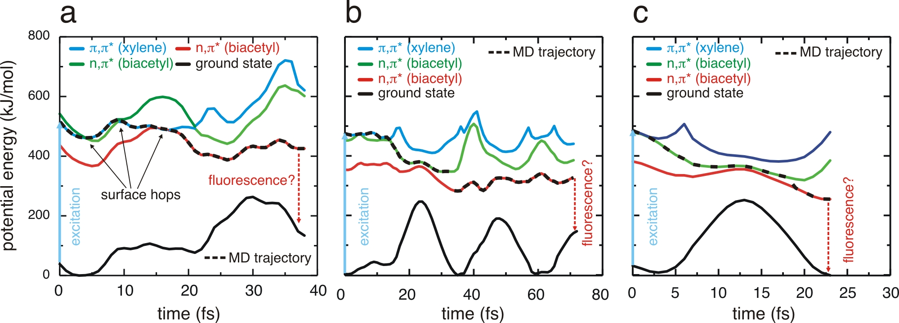

Figure 7. Potential energies of the three lowest excited states and ground state as a function of the simulation time for (a) the diabatic and (b, c) the fewest switches surface hopping trajectories. After excitation to the (π,π*) state localized on benzene (blue), nuclear relaxation dynamics leads to conical intersections with the two (n,π*) states localized on diketone (green and red). Eventually, the system gets trapped in the lowest (n,π*)1 state (red) and further decay to the ground state must occur by fluorescence.

Thus, the two nonadiabatic simulation approaches suggest different pathways for the intramolecular EET process. Diabatic hops are restricted to the seam, so that the character of the electronic states does not change upon hopping. Since the first seam is peaked and *n*-1 dimensional, the trajectory will not change the electronic character of the state. In contrast, despite the one-dimensional branching space, the nonadiabatic coupling is sufficiently strong to induce fewest switches surface hops before the trajectory reaches the seam. These hops transfer the trajectory from the (π,π*) to the (n,π*)2 surface, on which it evolves further until the next region of nonadiabatic coupling with the lower (n,π*)1 is reached. Note that this region is more accessible in the *intermediate* configuration based on the ab initio calculations, and which is confirmed in our trajectory. In the *compact* and *extended* configurations, the conical intersection is higher in energy so that it will take the trajectory longer to get near the (n,π*)2/(n,π*)1 conical intersection region. Despite the differences in the observed pathways between the two surface hopping approaches, the final result is identical in the sense that the electronic energy has been transferred from the acceptor (benzene moiety) to the acceptor (α-diketone moiety) via successive radiationless decays at various conical intersections. The results of the ab initio calculations and nonadiabatic MD simulations are consistent and suggest that in P44, the EET process is driven by nuclear dynamics and that conical intersections are the key mechanistic features in the reaction pathway.

A major shortcoming in our computations is the lack of dynamic electron correlation in the CASSCF approach. Due to the fairly extended size of the active space, it was only possible to recalculate energies of the critical CASSCF structures at the CASPT2 level of theory (Table S11 in Supp. Info.). The results of these computations show that the CASSCF potential energy landscape is qualitatively correct but the excitation energies are unsurprisingly inaccurate. Thus, at this point, our CASSCF results provide a mechanistic picture for the EET process, which require further confirmation from more accurate simulations not achievable at present or from state-of-the-art time-resolved experiments.

**5. Conclusions**

In this work we identified nonadiabatic reaction pathways for the intramolecular EET process in the bridged bichromophore dyad P44. Although these results require further validation, they suggest that Dexter theory may not be appropriate to model EET between chromophores at very close distances. Our EET mechanism is further supported by previous computational works, most notably Jolibois *et al*.[48],[49] and Fernandez-Alberti *et al*.[50] In recent literature there have been reports of EET process that cannot be explained by approach based on first order perturbation theory.11-13 In these systems, EET is efficient, despite very weak couplings between the excited states. Based on our simulations, we propose that also in these cases, the EET could be mediated by conical intersections. Ultimately, simulations like the ones presented here may not only contribute to a deeper understanding of the EET phenomena, but also aid in controlling this process by manipulating the nuclear dynamics.

**Acknowledgements**

We thank the Academy of Finland and the International Max Planck Research School “Physics of Biological and Complex Systems” for financial support to GG and CFB, respectively. This work was granted access to the HPC resources of CALMIP under the allocation 2015-p12158.

**References**

1. P. Wu, L. Brand, *Anal. Biochem.* 218, **1994**, 1.
2. R. M. Clegg, *Curr. Opin. Biotechnol.* 6, **1995**, 103.
3. Th. Förster, *Z. Naturforsch.* 49, **1949**, 321.
4. Th. Förster, *Z. Elektrochem. Angew. Phys. Chem.* 53, **1949**, 93.
5. Th. Förster, *Discuss. Faraday Soc.* 27, **1959**, 7.
6. Th. Förster, In *Modern Quantum Chemistry*, Ed., O. Sinanoglu, Academic Press: New York, 1968, Vol. 3, p. 93.
7. D. L. Dexter, *J. Chem. Phys.* 21, **1953**, 836.
8. E. Fermi, In *Nuclear Physics*, The University of Chicago Press, Chicago, Illinois, U.S.A, 1974.
9.
10.
11.
12.
13.
14. A. Ishizaki, T. R. Calhoun, G. S. Schlau-Cohen, G. R. Fleming, *Phys. Chem. Chem. Phys.* 12 (**2010**) 7319–7337.
15. R. Jankowiak, M. Reppert, V. Zazubovich, J. Pieper, T. Reinot, *Chem. Rev.* 111 (**2011**) 4546–4598.
16. L. A. Pachón, P. Brumer, *Phys. Chem. Chem. Phys.* 14 (**2012**) 10094–10108.
17. V. Tiwari, W. K. Peters, D. M. Jonas, *Proc. Natl. Acad. Sci. USA* 110 (**2013**) 1203–1208.
18.
19. S. Hassoon, H. Lustig, M. B. Rubin, S. Speiser, *Chem. Phys. Lett.* 98, **1983**, 345.
20. S. Speiser, J. Katriel, *Chem. Phys. Lett.* 102, **1983**, 88.
21. S. Hassoon, H. Lustig, M. B. Rubin, S. Speiser, *J. Phys. Chem. A* 88, **1984**, 6367.
22. S.-T. Levy, M. B. Rubin, S. Speiser, *J. Photochem. Photobiol. A: Chem.* 66 (**1992**) 159–169.
23. N. J. Turro, V. Ramamurthy, J. C. Scaiano, *Principles of Molecular Photochemistry*, University Science Books, California, USA, 2009.
24. E. Teller, *J. Phys. Chem.* 41 (**1937**) 109–116.
25. G. Herzberg, H. C. Longuet-Higgins, *Disc. Faraday Soc.* 35 (**1963**) 77–82.
26. G. J. Atchity, S. S. Xantheas, K. Ruedenberg, *J. Chem. Phys.* 95 (**1991**) 1862–1876.
27. D. R. Yarkony, *Rev. Mod. Phys.* 68 (**1996**) 985–1013.
28. D. R. Yarkony, *Acc. Chem. Res.* 31 (**1998**) 511–518.
29. C.-P. Hsu, *Acc. Chem. Res.* 42 (**2009**) 509–518.
30. A. D. Becke, *J. Chem. Phys.* 98 (**1993**) 5648–5652.
31. W. J. Hehre, R. Ditchfield, J. A. Pople, *J. Chem. Phys.* 56 (**1972**) 2257–2261.
32. P. C. Hariharan, J. A. Pople, Theor. Chim. Acta 28 (**1973**) 213–222.
33. C. Gonzalez, H. B. Schlegel, *J. Phys. Chem.* 94 (**1990**) 5523–5527.
34. P. Celani, H. J. Werner, *J. Chem. Phys.* 112 (**2000**) 5546–5557.
35. T. H. Dunning, *J. Chem. Phys.* 90 (**1989**) 1007–1023.
36. M. Boggio-Pasqua, G. Groenhof, *Comput. Theor. Chem.* 1040–1041, **2014**, 6–13.
37. G. A. Worth, M. A. Robb, *Adv. Chem. Phys.* 124 (**2002**) 355–431.
38. W. F. van Gunsteren, S. R. Billeter, A. A. Eising,  P. H. Hünenberger, P. Krüger, A. E. Mark, W. R. P. Scott, I. G. Tironi, *Biomolecular Simulation: The GROMOS96 Manual and User Guide*, Vdf Hochschulverlag, Zürich, 1996.
39. G. Groenhof, L. V. Schäfer, M. Boggio-Pasqua, M. A. Robb, Excited state dynamics in biomolecules, In *Handbook of Molecular Biophysics*, Ed. H. Bohr, Wiley-VCH, Weinheim, **2009**, pp. 93–134.
40. G. Groenhof, M. Boggio-Pasqua, L. V. Schäfer, M. A. Robb, *Adv. Quantum Chem.* 59, **2010**, 181–212.
41. M. Boggio-Pasqua, C. F. Burmeister, M. A. Robb, G. Groenhof, *Phys. Chem. Chem. Phys.* 14, **2012**, 7912–7928.
42. J. C. Tully, R. K. Preston, *J. Chem. Phys.* 55 (**1971**) 562–572.
43. J. C. Tully, *J. Chem. Phys.* 93 (**1990**) 1061–1071.
44. J. C. Tully, *Int. J. Quantum Chem.* 40 (**1991**) 299–309.
45. G. Granucci, M. Persico, A. Zoccante, *J. Chem. Phys.* 133 (**2010**) 134111.
46. H.-J. Werner, P. J. Knowles, G. Knizia, F. R. Manby, M. Schütz, P. Celani, T. Korona, R. Lindh, A. Mitrushenkov, G. Rauhut, K. R. Shamasundar, T. B. Adler, R. D. Amos, A. Bernhardsson, A. Berning, D. L. Cooper, M. J. O. Deegan, A. J. Dobbyn, F. Eckert, E. Goll, C. Hampel, A. Hesselmann, G. Hetzer, T. Hrenar, G. Jansen, C. Köppl, Y. Liu, A. W. Lloyd, R. A. Mata, A. J. May, S. J. McNicholas, W. Meyer, M. E. Mura, A. Nicklaß, D. P. O’Neill, P. Palmieri, D. Peng, K. Pflüger, R. Pitzer, M. Reiher, T. Shiozaki, H. Stoll, A. J. Stone, R. Tarroni, T. Thorsteinsson, M. Wang, MOLPRO, version 2009.1, a package of ab initio programs, see http://www.molpro.net.
47. Van der Spoel, D.; Lindahl, E.; Hess, B.; Groenhof, G.; Mark, A. E.; Berendsen, H. J. C. *J. Comp. Chem*., **2005**,  *26*, 1701–1718.
48. F. Jolibois, M. J. Bearpark, S. Klein, M. Olivucci, M. A. Robb, *J. Am. Chem. Soc.* 122 (**2000**) 5801–5810.
49. F. Jolibois, M. J. Bearpark, M. A. Robb, *J. Phys. Chem. A* 106 (**2002**) 4358–4367.
50. M. A. Soler, A. E. Roitberg, T. Nelson, S. Tretiak, S. Fernandez-Alberti, *J. Phys. Chem. A* 116 (**2012**) 9802–9810.